Important remark:
During S20, Brussels Airport Company will do critical works on runway 25R/07L.
As a result of the works, the capacity of BRU/EBBR will be reduced during the works.
The renovation is scheduled to last for six weeks from Monday 13 July to Sunday 23 August 2020, with runway 25R/07L entirely closed for air traffic 24/7. This means that this runway is not available for take-off or landing.
The Coordination Committee agreed the reduction of coordination parameters as shown in the tables here below.
Depending the operational conditions of the day, heavy delays and longer holding sequences are possible during the period of the works.
Because of the important reduction of capacity during works, BSC may impose to operators to change schedules of historic flights in order to match the capacity available.

Coordination parameters 1: before and after the period of works on runway 25R
Valid : From 29 March 2020 until 12 July 2020 and from 24 August 2020 until 24 October 2020
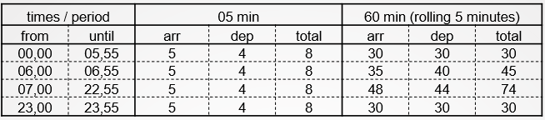
times are local
Coordination parameters 2: period of works on runway 25R.
Valid : From 13 July 2020 until 23 August 2020

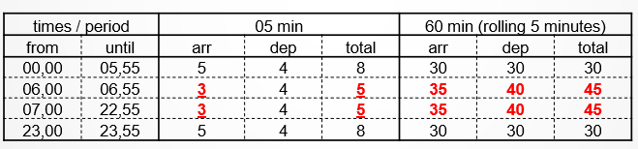
times are local
Number of night slots available.

Ministerial Decree of 21 January 2009 sets the limits of the number of night slots that the airport coordinator to maximum 16.000 slots per calendar year including a maximum of 5.000 slots for departures.

Restriction on departures in the week-end nights (by Ministerial Decree of April 2009)

No airport slot may be allocated by the coordinator for departing flights in following periods:

